The Ottawa Diocesan is celebrating 100 Years!
Submitted by Claudette Langdon, Ottawa Diocesan President

The Ottawa Diocesan Council of the Catholic Women’s League of Canada was inaugurated in September of 1923 with the approbation and the blessing of His Excellency, the Most Reverend J.M. Emard., D.D. the Archbishop of Ottawa. The first Diocesan President was Mrs. M.J. Lyons and the first Spiritual Advisor was Canon J. Edgar Brennan.

Throughout the 100 years we had the honour of having 15 Diocesan Spiritual Advisors who provided us guidance. We also had 50 women shared their gifts with the Ottawa Diocesan Council since 1923, each as unique as the first.

We currently have 24 Parish Councils. Here are a few of the oldest parishes:
- ST. CATHERINE OF SIENA
The CWL began at St. Catherine’s Parish, in Oct. 1925. (Charter # 334).
- ST. IGNATIUS THE MARTYR
On April 29,1930, Charter #497 was issued to the CWL subdivision of St. Joan of Arc Parish, Overbrook.
- ST. MARY’S (ALMONTE)
St. Mary’s Almonte CWL Council was founded on September 19th, 1937.
- ST. PATRICK (FALLOWFIELD)
St Patrick’s Fallowfield Catholic Women’s League was granted a Charter on Oct.7, 1944. First dues were 50 cents per member.
- OUR LADY OF THE VISITATION
The first Catholic Women’s League Council #1771 formed in December 1954.
- IMMACULATE HEART OF MARY
The IHM CWL Council was organized on October 6th, 1958.

100th Annual Convention

Our 100th Annual Convention was held on May 13, 2023 hosted by St. Patrick’s Parish (Fallowfield) with 97 members registered. We celebrated the spiritual and social joys of membership in The Catholic Women’s League of Canada.

We had the honour of our Provincial President, Linda Squarzolo attend our last convention and provide provincial greetings.

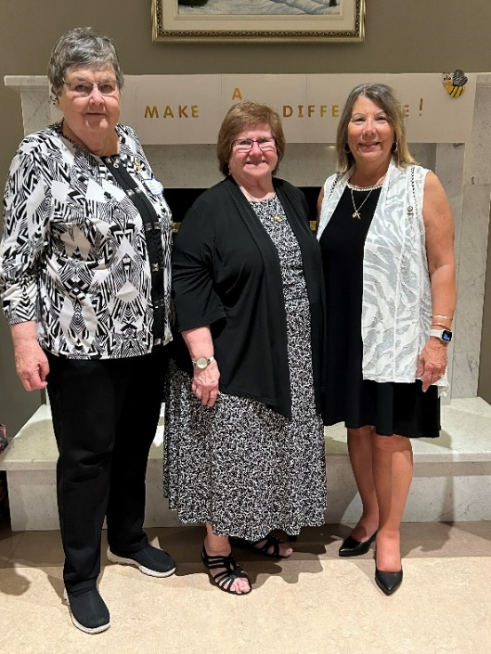
Pictured: Joanna Sisk- Life Member Liaison/Provincial Legislation Standing Committee Chair, Linda Squarzolo, Provincial President and Claudette Langdon Ottawa Diocesan President.

We were also graced with ladies from the Alexandria-Cornwall Diocesan attending our convention.

To celebrate our 100 years, an Anniversary History Booklet was created detailing our history and that of our Parish Councils. Each member who attended was provided a copy of the booklet with a Medal of The Miraculous Medal Bookmarker.

We had two Guest Speaker throughout the day. The first guest speakers were Donna Naughton, an Indigenous Elder and Gerry Kelly, Manager of Spiritual Programs Galilee Centre. Their talk was entitled “Shadow of Wardship”. They spoke about the history of the Indigenous People. Donna has many relatives who were survivors of the residential schools and it had a profound effect on her life. Their talk was very interesting and inspiring. Donna was given a beautiful stain glass feather gifted from Colleen Martin, Provincial President-Elect/Organization and a token of our appreciation.

The second speaker was Sarah Oswald of the Caldwell Family Centre. The theme of her talk was “In our Community, No One Goes Hungry”. The Caldwell Family Centre operates in a large area of Ottawa and they provide food for their community and surrounding areas. The Caldwell Family Centre was the recipient of charitable donations collected and offered by members in attendance at the convention.

The Crowning of Mary, always a spiritual highlight was a wonderfully ceremony with a special prayer service and flowers to honour our deceased sisters.

Parish Presidents provided an oral or a visual display to show how their Councils ‘Made a Difference’. There were many beautiful visual displays, we are only showing a few.

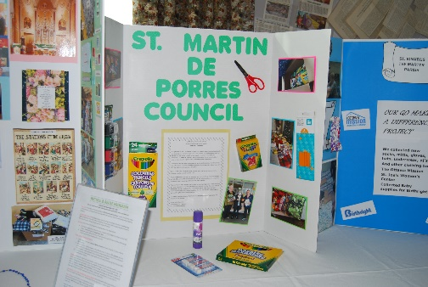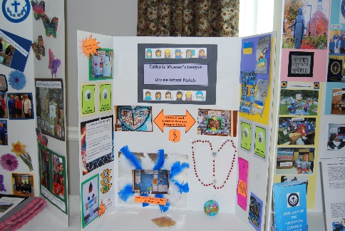

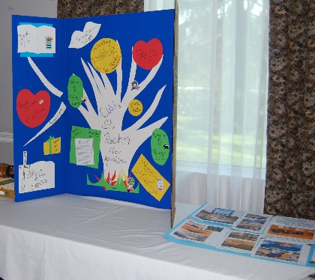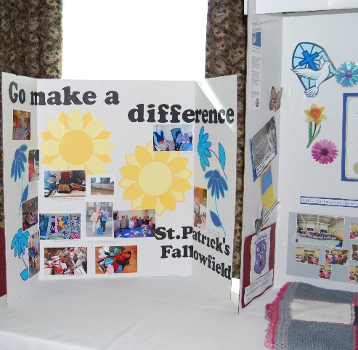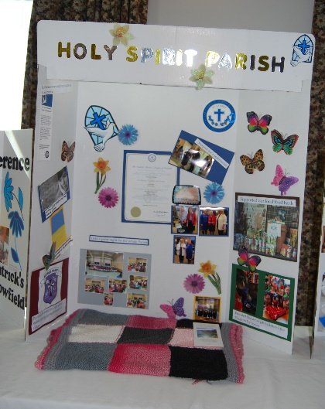

Our Diocesan Officers reports were based on ‘How they made a Difference in their positions’. Their work was invaluable to the success of our diocesan.

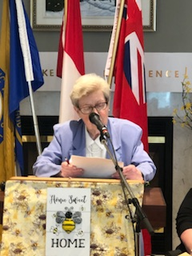
Pictured: Life Member and Diocesan Treasurer, Shirley Bernier.

As Diocesan President I witnessed firsthand our members’ faith, dedicated service and social justice work. Our diocesan members worked diligently responding to the provincial theme of 'Go Make a Difference’. They were productive CWL BEES! Their flights were spiritual! The reports and displays showed that they ‘Made a Difference’ They should be proud!

The Parish displays and reports also reflected parish work for the Standing Chairs of Faith, Service and Social Justice. The presentations highlighted their work and dedication.

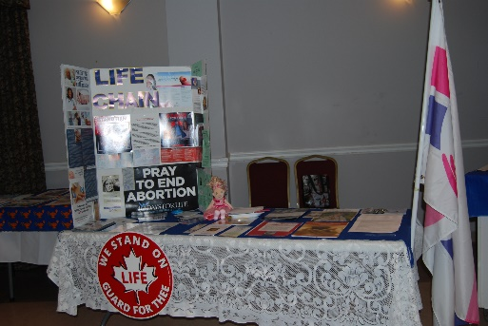

St. Augustine tells us, “Because You have loved me, O Lord, You have made me lovable.”

To honour our 100 years we had tables to show our rich history with information found in the archives.

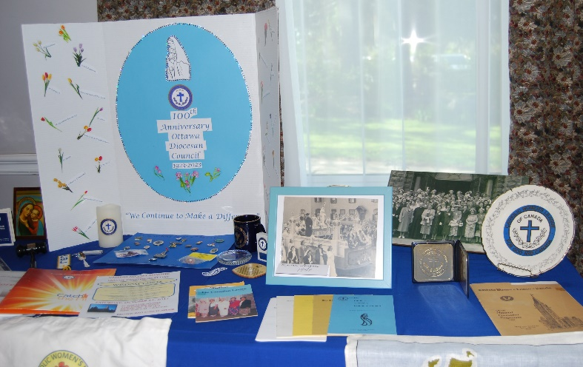
One item was a picture taken from the first Ottawa Annual Convention on the steps of the Fairmont Chateau Laurier!

The Ottawa Diocesan was gifted a resolution from Leonard’s Parish Council: “Canada to Honour its Commitment to the UN 2030 Agenda, Number 6, for Sustainable Development to provide clean, accessible water for all First Nations.” The motion to accept the resolution was passed and it will now go to Provincial for approval.
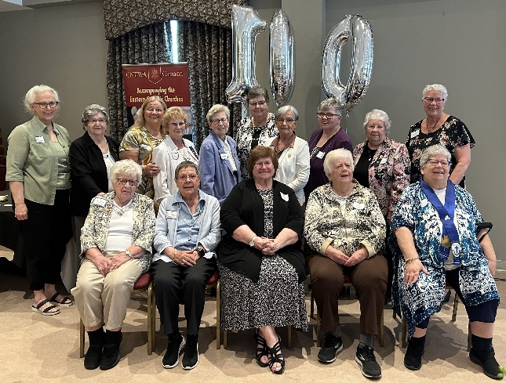

There was a tribute to our Life Members who are the ‘jewels’ our Diocesan.

Pictured is the Ottawa Diocesan Life Members with visiting Life Members who attended the convention…What gifts!

Pope Francis was quoted with the following: “Women make the world beautiful; they protect it and keep it alive. They bring the grace of renewal, the embrace of inclusion, and the courage to give of oneself”. Members lived this through their spirituality and actions.

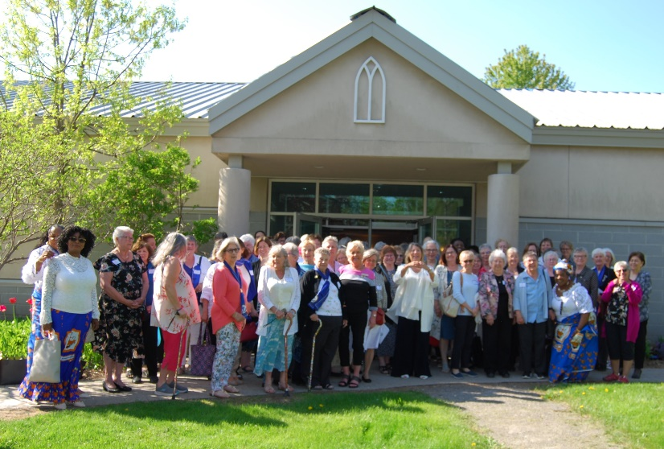
Group Picture of Members in attendance.
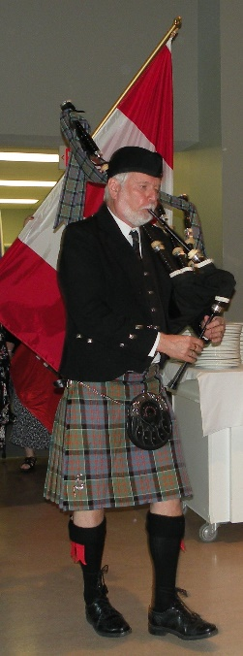

Our banquet began with the colour party being piped in by Donald MacDonald. What lovely way to begin our Banquet!

Our Mistress of Ceremonies for the evening banquet was Joanna Sisk, Life Member Liaison, Provincial Legislation Standing Committee Chair and part-time Beekeeper!
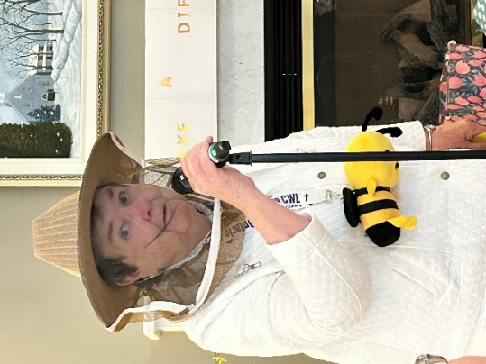
Our special guests at the banquet were Provincial President, Linda Squarzolo and The Most Reverend Archbishop Damphousse of Ottawa-Cornwall.

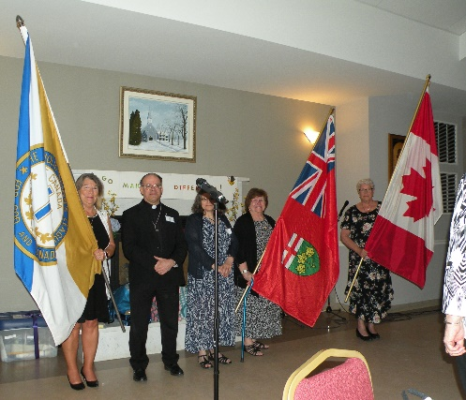

After our dinner we were provided entertainment from one of our long serving CWL ladies acting as the First Ottawa Diocesan President, Mrs. M. Lyons. A presentation was made by our Life Member Liaison, Joanna Sisk on the fashions over the 100 years.

Our Honorary Life Member, Joan Chesser opened a Time Capsule with historical items and

We concluded our celebration with a 100th Anniversary Cake celebration and music.

It was a wonderful way to end as the Ottawa Diocesan Council and embrace the future of the new Ottawa-Cornwall Diocesan! Exciting times are ahead!

100th Anniversary Tree Planted

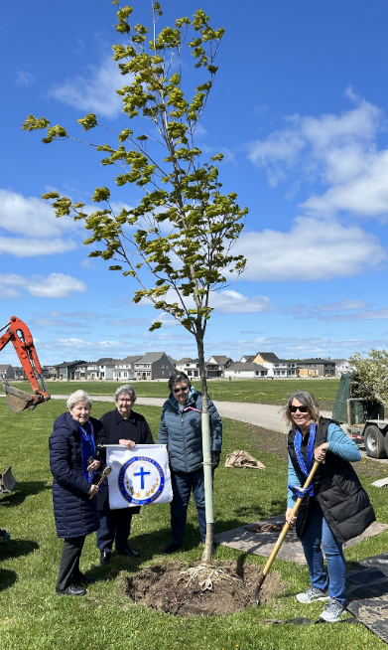
The Ottawa Diocesan planted a 100th Anniversary Tree at Hope Cemetery on a cold May 17, 2023 to honour our history!

Pictured: Shirley Bernier-Life Member, Evelyn Meaney-Life Member, Joanna Sisk Life Member Liaison and Claudette Langdon Ottawa Diocesan President.

May Our Lady of Good Counsel watch over us as we continue your service for ‘God and Country’.

